Chapter 11, Problem 59.

Calculate the reactive power in the inductor and capacitor in the circuit of
Fig. 11.78.

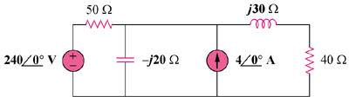

Figure 11.78
For Prob. 11.59.

